* 1. First window:

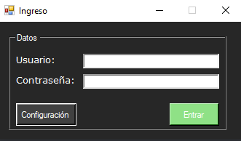

The login screen, as is, the first window shown, requests the user to enter their login credentials. For the first blank field, one shall enter their username. Likewise, in the second field, the password.

If the data is valid, the user could choose whether to enter the configuration screen or proceed into the main screen.

* 1. Configuration screen:

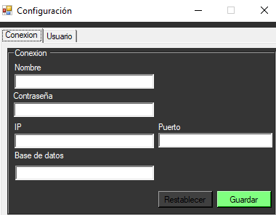

The first thing the user could appreciate is the several text fields allowing the user to add or modify login info, each field with their corresponding datatype. It also has the option to return to their default values, or save changes.

In addition to this, it has a tab to manage users (only available if the user has enough permissions).

* 1. Users tab:

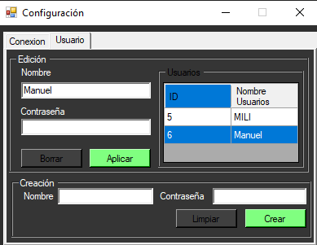

The users tab presents an user creation section as well as an user editing section.

The user creation section offers a name field and a password field, for the administrator to set the new user's credentials. Down below there exists a button to finish up and create the new user, as well as other one to clear all text fields.

The user editing section shows a table with every user's id and username. Upon selecting any of them, the section will be filled up with the selected user's data, allowing the administrator to modify their name and/or password. Afterwards, the administrator can either apply or discard the changes made.

1. Home screen:

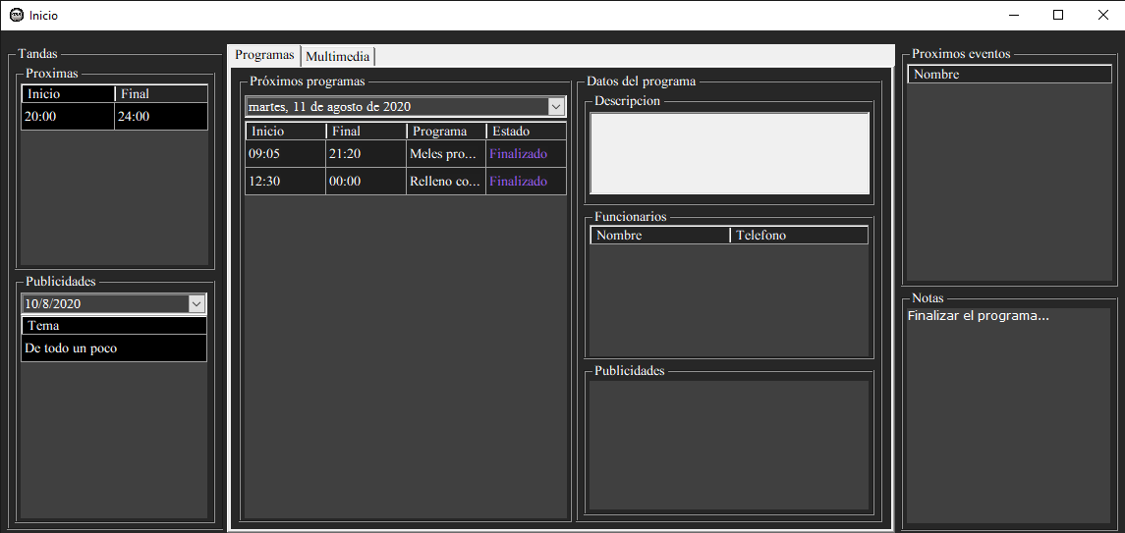

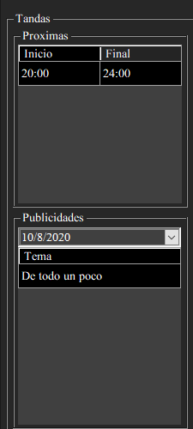

a- The left region of the main interface is dedicated to batches.

The upper division can display the next batches, showing the start time and the end time. While the lower division shows the topics of the advertisements, along with the date, which the user can search for a specific one.

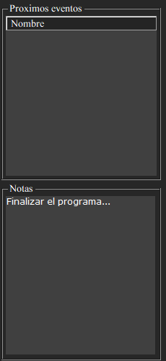

b- The right region of the interface, in the upper division, is dedicated to upcoming events, showing the name and date of the event. In the lower division there is a note box for the user to write some reminder.

c- Several tabs are displayed in the central region.

Programs tab:

Scheduled Programs: The next programs are displayed, in which you can select a desired date and the assigned programs will be shown with their corresponding data.

Clicking on any program on the left side will show more information about that program.

Search program:

Search button: when entering data in the upper fields, these programs are searched

Enter button: the data entered in the fields will be entered as a new program.

Delete button: deletes the selected program from the table.

Clear search button: clears the list of programs in the table.

Series tab:

Search series:

Search button: when you enter data in the upper fields, the search is done by the name or the date of the series.

Enter button: the data entered in the fields, will be entered as a new series.

Delete button: delete the series selected in the table.

Clear search button: clears the list of series in the table.

Search video:

Search button: Search the videos with this information entered in the fields, you can include the date to search it, by the name or its content.

Enter button: The data entered in the fields will be registered as a new video.

Delete button: delete the selected video from the table.

Clear search button: clears the list of videos in the table.

Companies tab:

Search button: when entering data in the upper fields, the information is searched for customers/companies.

Enter button: The information is entered in the upper fields and a new client is registered.

Delete button: Deletes the client that is selected in the table.

Clear search button: clears the list of clients in the table.

Advertising tab:

Search button: when entering data in the upper fields, the information of the advertisements is searched, they can be searched including the face, name and/or by the company that hired them.

Enter button: The information is entered in the upper fields and a new advertisement is registered.

Delete button: Deletes the advertisement selected in the table.

Clear search button: clears the list of advertisements in the table.

Civil servant:

Search official:

Search button: when entering data in the upper fields, the information is searched for the officials who are registered, showing their contact information in the table.

Enter button: The information is entered in the upper fields and a new official is registered.

Delete button: Deletes the official selected in the table.

Clear search button: clears the list of officials in the table.

Search function:

Search button: when data is entered in the upper fields, the name and description of the function is searched and displayed in the lower table.

Enter button: The information is entered in the upper fields and a new function is registered.

Delete button: delete the function that is selected in the table.

Clear search button: clears the list of functions in the table.

Event tab:

Search button: when entering data in the upper fields, the events are searched and displayed in the table.

Enter button: The information is entered in the upper fields and a new event is registered.

Delete button: Deletes the selected event from the table.

Clear search button: clears the list of events in the table.